Hosting a Static Website on AWS S3
  - Project 01 — Cloud Portfolio Website

Step 1: Open the Amazon S3 Buckets Page
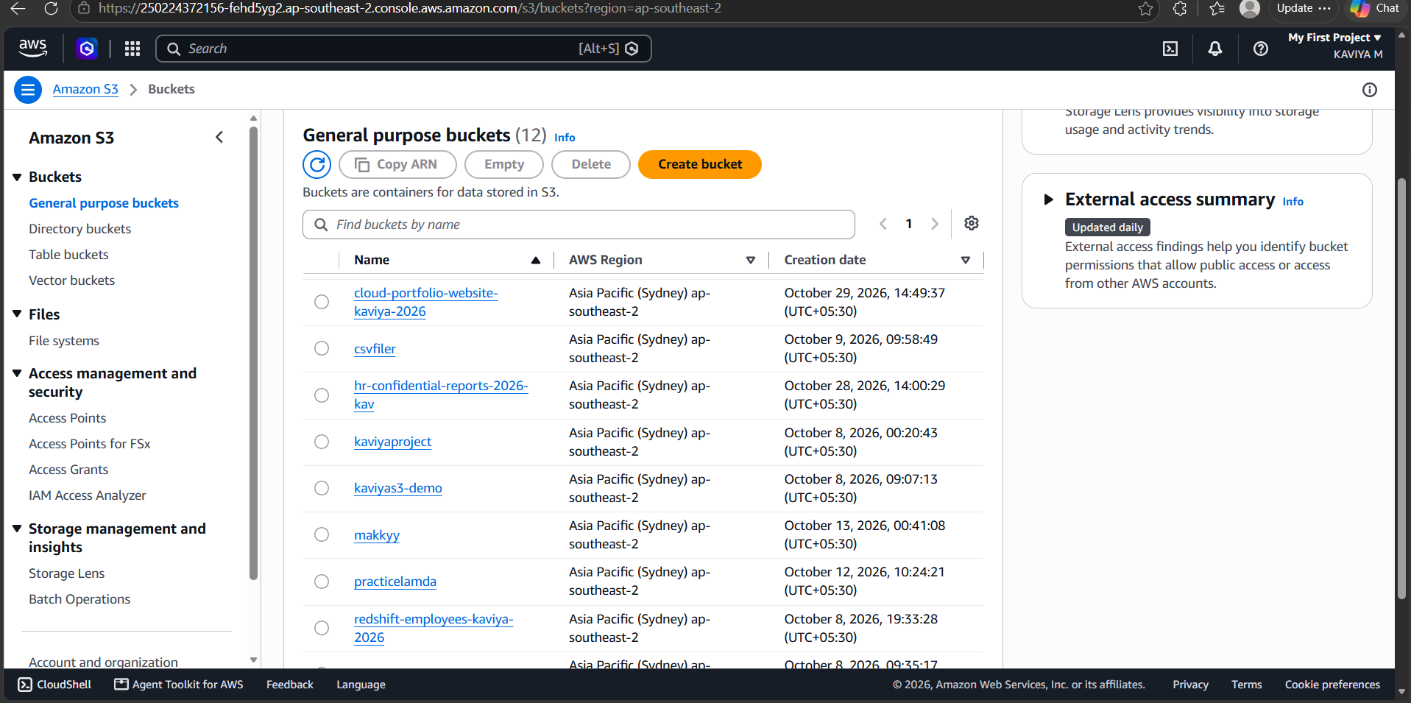
Figure 1: Amazon S3 console showing the list of general purpose buckets, including the new bucket cloud-portfolio-website-kaviya-2026

Step 2: Upload the index.html File
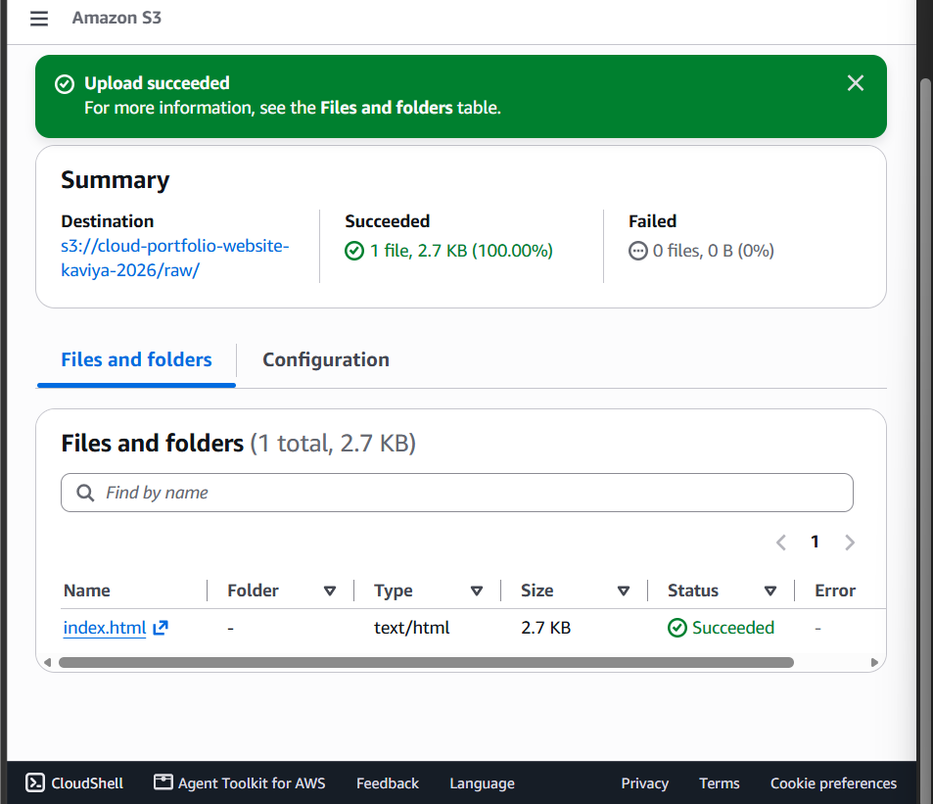
Figure 2: Upload succeeded: index.html (2.7 KB) uploaded to the S3 bucket

Step 3: Enable Static Website Hosting
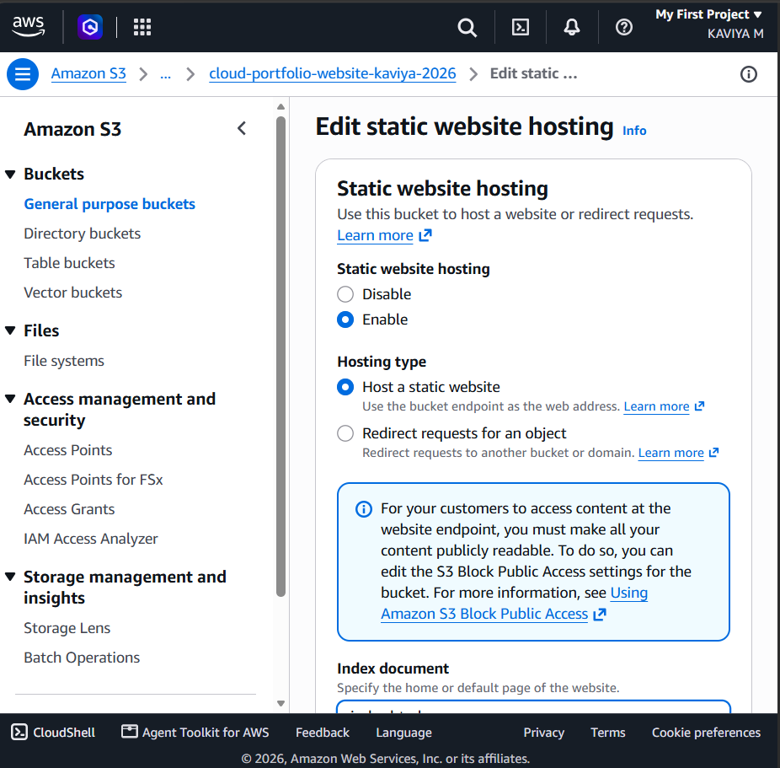
Figure 3: Edit static website hosting page with hosting enabled and the hosting type set to Host a static website

Step 4: Confirm Static Website Hosting Is Saved
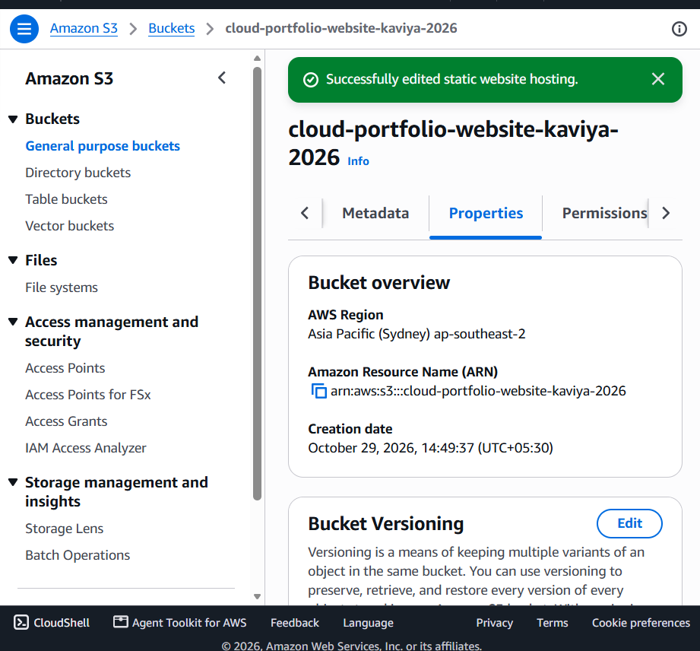
Figure 4: Success message confirming static website hosting was edited, shown on the bucket Properties tab

Step 5: Open the Block Public Access Settings
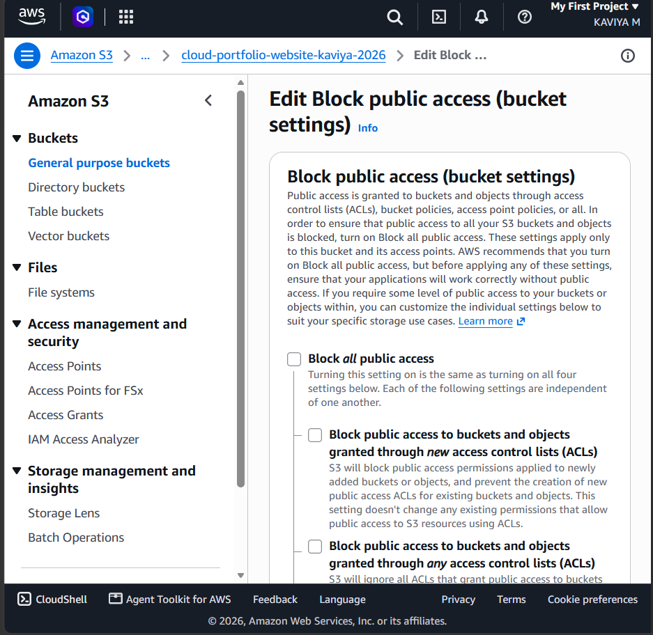
Figure 5: Edit Block public access (bucket settings) page with Block all public access unchecked

Step 6: Confirm Block Public Access Is Turned Off
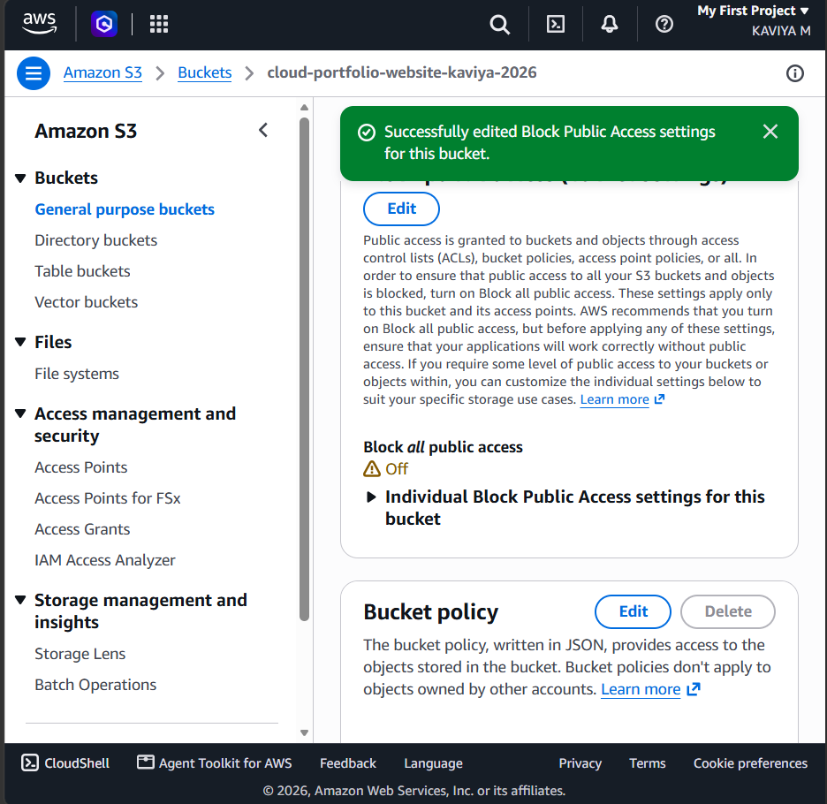
Figure 6: Success message confirming the Block Public Access settings were edited, with Block all public access showing Off

Step 7: Add the Bucket Policy for Public Read
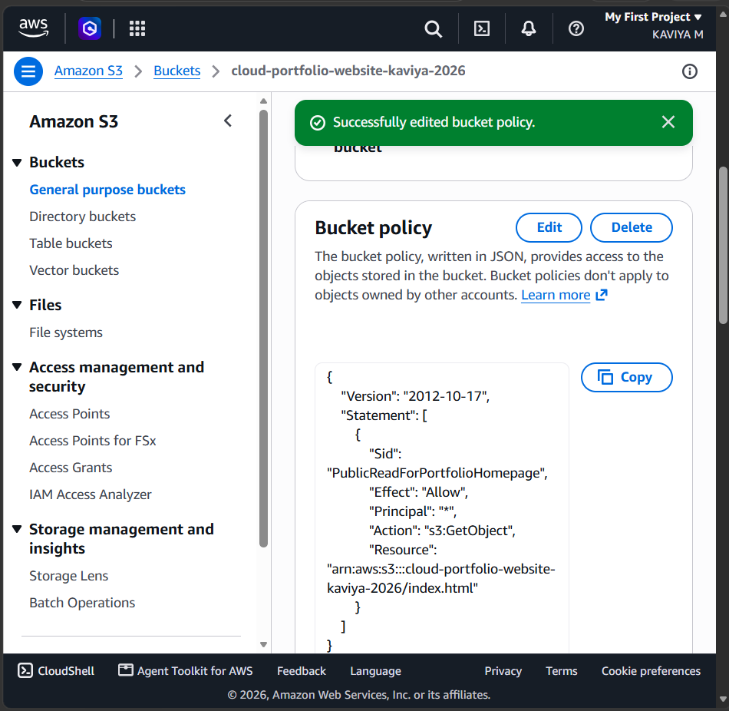
Figure 7: Bucket policy saved successfully, allowing public s3:GetObject access to index.html

Step 8: Copy the Bucket Website Endpoint
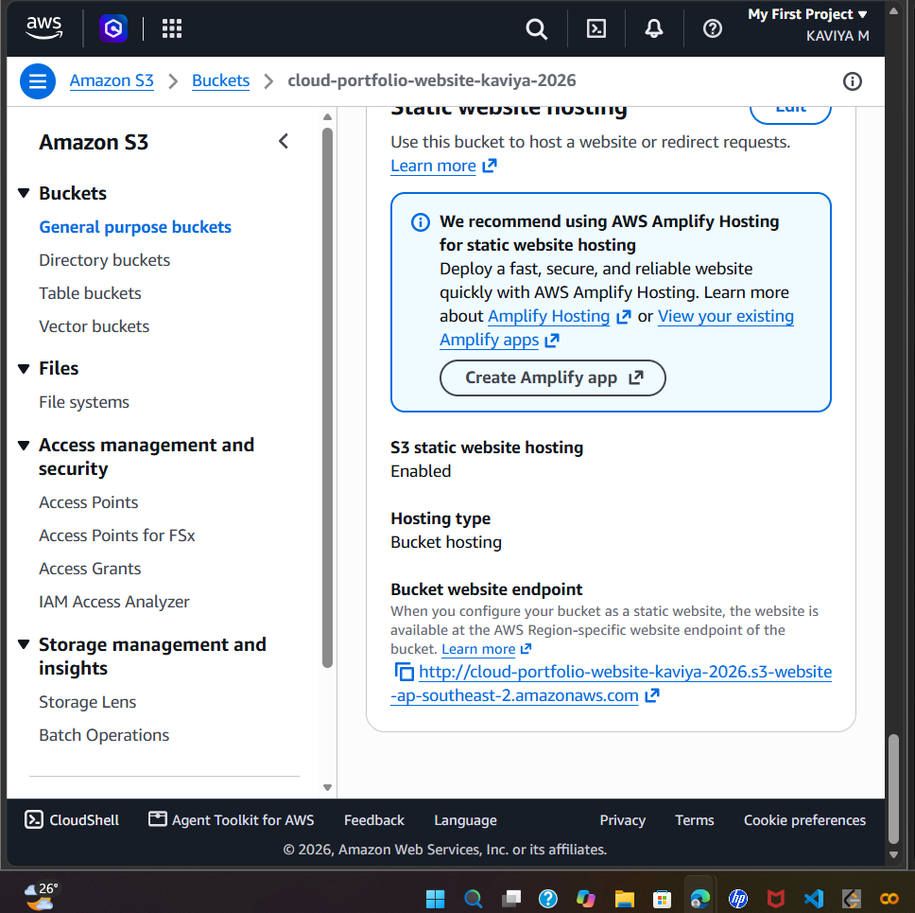
Figure 8: Properties tab showing S3 static website hosting enabled and the bucket website endpoint URL

Step 9: View the Live Website
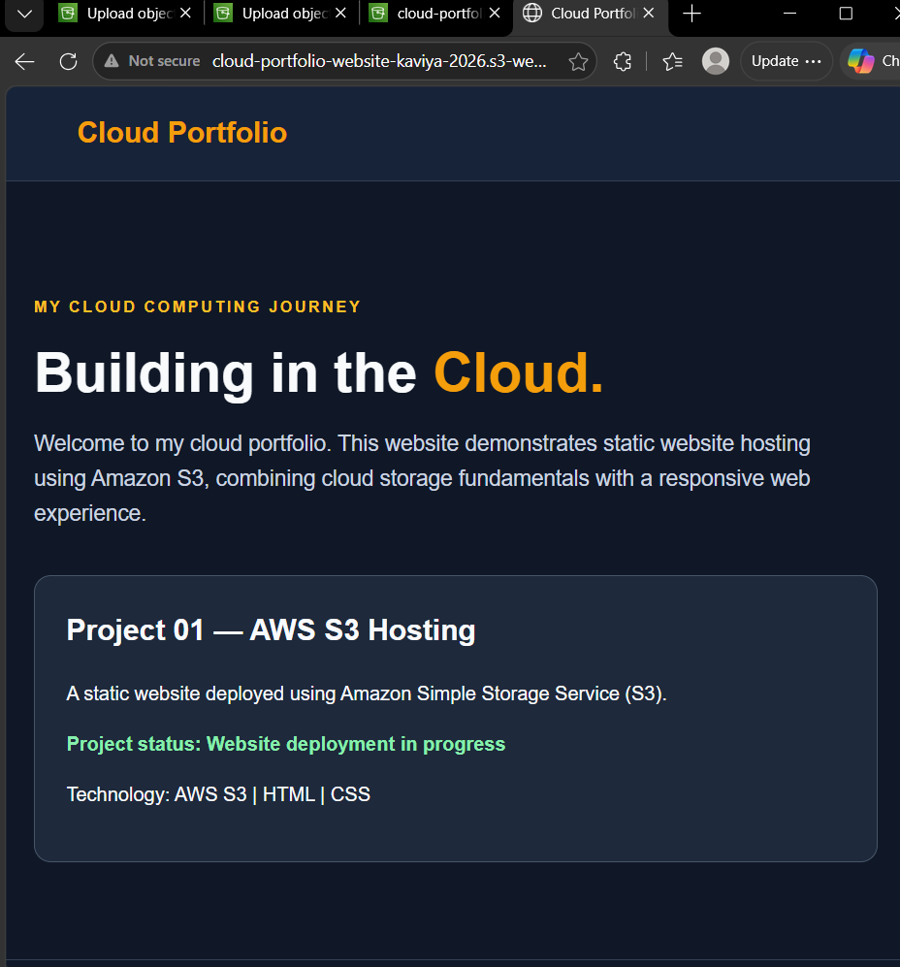
Figure 9: Deployed Cloud Portfolio website opened in the browser through the S3 website endpoint

